Source https://www.viator.com/tours/Male/Guided-Snorkeling-Trip/d4673-211090P2
__________________________________________________________

Maldives Reef Discovery: Guided Snorkeling Adventure
__________________________________________________________
★★★★★ 4.7/5 20 reviews

Add to wishlist ♡

__________________________________________________________

2 hours | €165 per person

🏕  Image | 🏕  Image | 🏕  Image | 🏕  Image | 🏕  Image | 🏕  Image

__________________________________________________________
About This Tour
Dive into a vibrant underwater paradise on this guided snorkeling adventure in the Maldives. Led by experienced professionals, this excursion takes you to some of the region’s most breathtaking reef locations where you can encounter colorful fish, coral gardens, sea turtles, and even graceful stingrays. Designed for both beginners and confident swimmers, this experience combines safety, comfort, and unforgettable marine encounters in one seamless ocean journey.
__________________________________________________________
What’s Waiting for You
- Duration: 2 hours
- Group Size: Small group (max 10 participants)
- Accommodation: Not included — activity only
- Languages Available: English
- Private Guide: Not included (professional guide provided)
- Transportation: Boat transport to snorkel sites included
- Season: Available year-round
- Meeting Point: Hulhumale Excursion Jetty (Lakudi Jetty), Malé — optional pickup from Hulhumale Island hotels
__________________________________________________________

Check Dates & Availability

Select participants: (Age 99 and younger) - 1 +

Choose date:
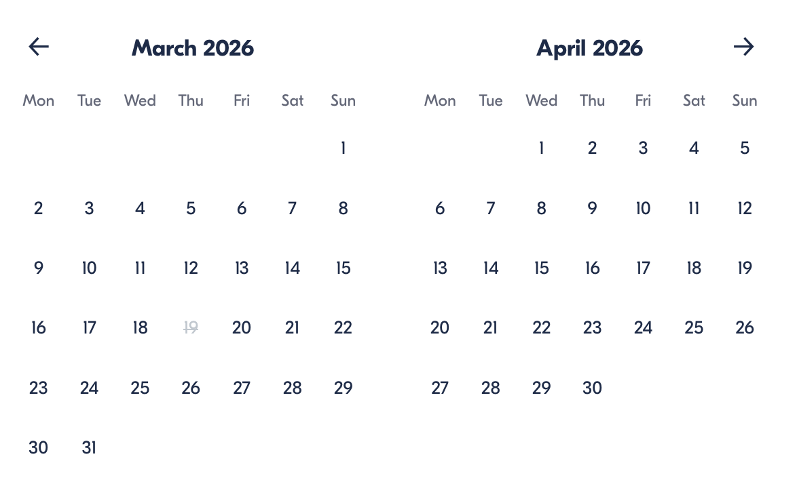

Check Availability

opens:

Participants: 1 March 16, 2026

Maldives Reef Discovery: Guided Snorkeling Adventure

- Duration: 2 hours
- Offered in: English
- Starts at: 4:30 PM

Cancellation:

- More than 24 hours before start — Full refund
- Less than 24 hours before start — No refund

Price breakdown: 1 Participant x €165

Total: €165

The total price includes all taxes and fees.

Add to cart Book now

__________________________________________________________
Tour Features
- Coral Garden Exploration: Discover protected reefs teeming with marine life
- Shark Point Adventure: Visit one of the Maldives’ most famous snorkel sites
- Wildlife Encounters: Spot rays, turtles, and tropical fish
- Expert Guidance: Learn about reef ecosystems from a professional guide
- Beginner Friendly: Suitable for swimmers and non-swimmers alike
__________________________________________________________
Detailed Itinerary
Meet & Departure
Arrive at Hulhumale Excursion Jetty, where your guide will brief you on safety procedures and the day’s snorkel route before boarding your boat.
Snorkeling Exploration
Travel to carefully selected reef locations such as Coral Garden, Stingray Point, Turtle Point, or Shark Point, depending on sea conditions. Each location offers different marine species and underwater landscapes.
Marine Encounters
Swim among vibrant coral formations and observe marine wildlife in its natural habitat while your guide assists and ensures safety throughout the experience.
Relax & Return
After your underwater exploration, relax on board with drinking water as you cruise back to shore filled with unforgettable ocean memories.
__________________________________________________________
Included in Price
- Professional snorkeling guide
- Snorkeling equipment
- Life jackets
- Bottled water
- Boat transfers to reef sites
- All taxes and fees
__________________________________________________________
Not Included
- Underwater camera rental
- Private transportation outside the Hulhumale pickup zone
- Personal expenses
- Gratuities
__________________________________________________________
Who Should Avoid This Tour
- Wheelchair Users: Boat access and water entry are not accessible
- Travelers With Serious Medical Conditions: Ocean activity may be physically demanding
- Guests Unable to Enter Water Safely: Basic mobility required for snorkeling
__________________________________________________________
Important Trip Info
- Confirmation is received at booking
- Maximum group size: 10 travelers
- Infant seats available
- Location is near public transportation
- Weather conditions may affect snorkeling locations
- Complimentary pickup available only for Hulhumale hotels
- Non-swimmers are welcome but must wear life jackets
__________________________________________________________

Cancellation Policy
- More than 24 hours before start: Full refund
- Less than 24 hours before start: No refund
__________________________________________________________
What Our Clients Are Saying

Overall rating  4.7/5  ★★★★★  Based on 20 reviews | Review summary  Guide 4.5/5  Transportation 4.6/5  Service 4.7/5  Organisation 4.5/5

Filter  - All traveller types  - Couples  - Group of friends  - Families  By star rating  - All star ratings  - 5 stars  - 4 stars  - 3 stars  - 2 stars  - 1 star | Search reviews (e.g., guide)  Sort by:  - Top picks  - Latest reviews  - Best ratings  - Lowest ratings
__________________________________________________________
★★★★★
Luca R. — Italy
An unforgettable snorkeling trip! The guide was fantastic, and swimming with turtles and colorful fish was magical.
★★★★☆
Maria L. — Spain
Great experience with beautiful reefs and a helpful guide. Visibility wasn’t perfect due to the weather, but still amazing.
★★★★★
Daniel H. — United States
Absolutely worth it! The coral formations were stunning, and our guide made sure everyone felt comfortable in the water. We even spotted a turtle gliding past us — an unforgettable moment.
★★★★☆
Camille D. — France
Very well-organised excursion with professional staff. The snorkeling spots were beautiful and not overcrowded. I would have loved a bit more time in the water, but overall a fantastic experience.
★★★★★
Aarav P. — India
Perfect short adventure in the Maldives. Clear water, vibrant fish, and excellent safety briefing. The small group size made it feel personal and relaxed. Highly recommend for first-time snorkelers.
See more reviews
__________________________________________________________

Meta tags

Page - Maldives Reef Discovery: Guided Snorkeling Adventure

Title: Maldives Reef Discovery: Guided Snorkeling Adventure | Travellio Global

Description: Explore the Maldives’ underwater paradise on a guided snorkeling tour. Swim among coral reefs, sea turtles, and tropical fish with expert guides and included equipment.

H1 - Maldives Reef Discovery: Guided Snorkeling Adventure
__________________________________________________________

